**19.AWS-S3-Part-1**

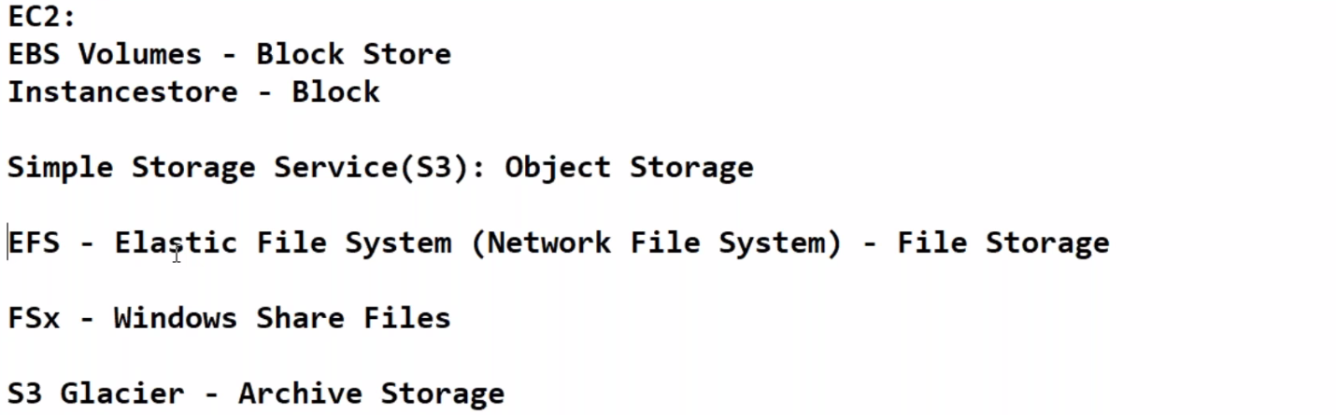

--- So far, we have seen 2 storages 1. EBS (elastic block storage) 2. Instance storage these 2 are block storages.

--- In s3 we can store any type of file. Like google drive.

--- **QUES** **Is s3 global…?**

S3 is partially global, why because we can see all buckets in one window. We don’t need to change the windows like EC2. S3 bucket is regional because when click on the create bucket option it will ask you the region.

**S3 BUCKET CREATING**

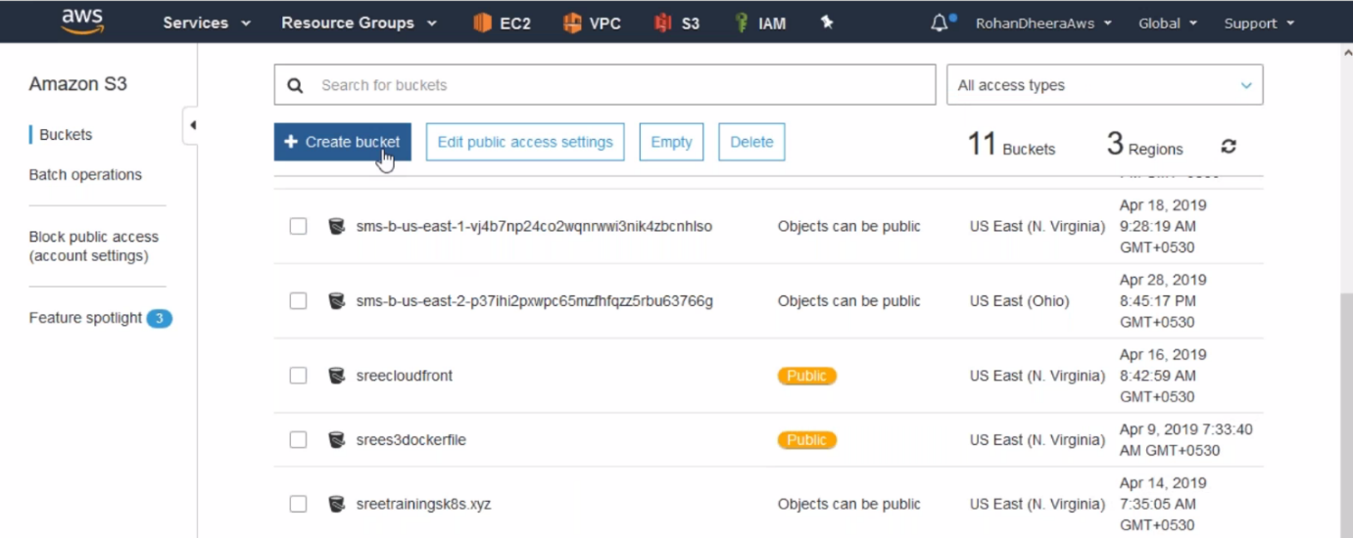

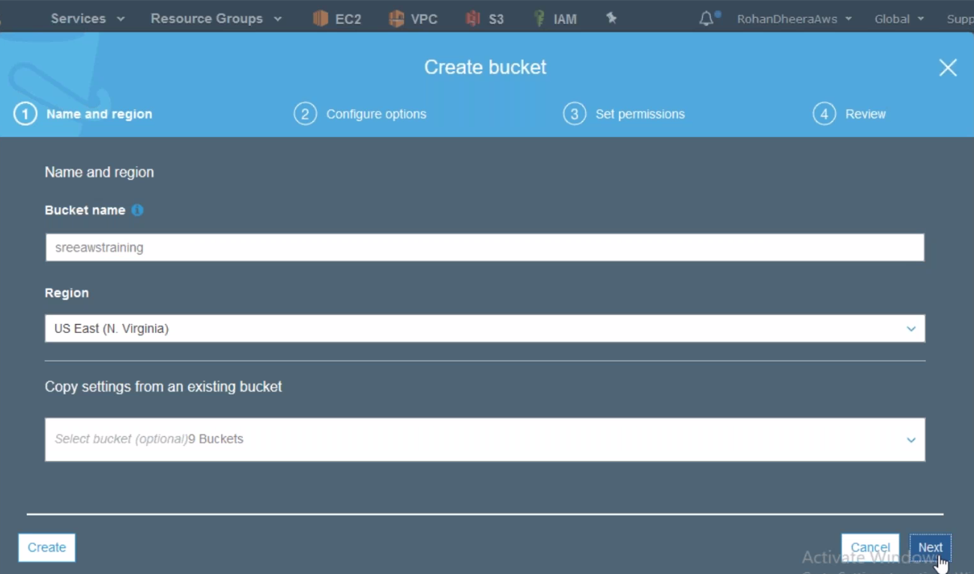

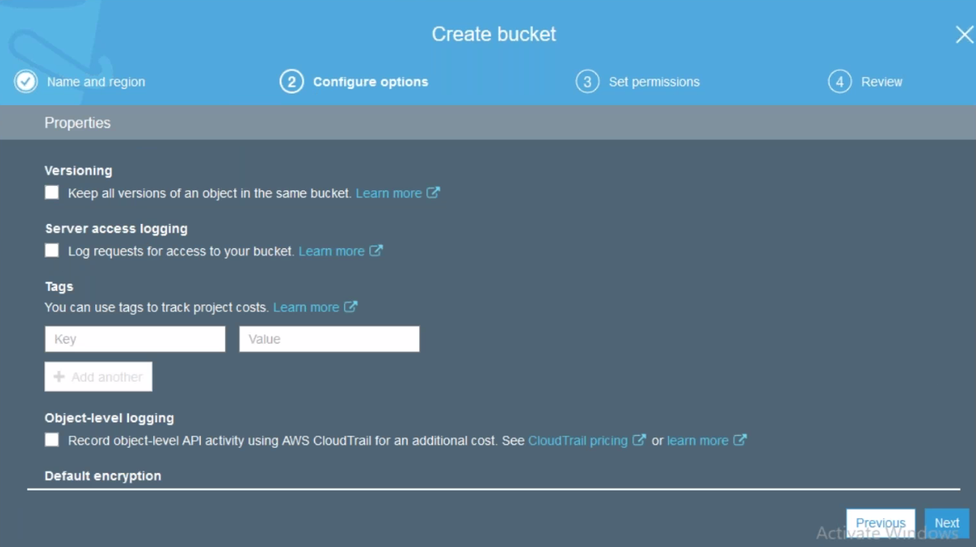

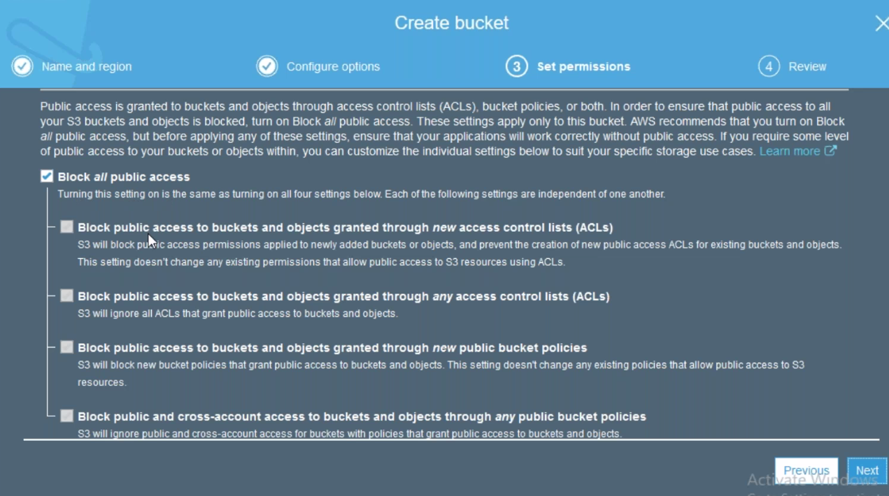

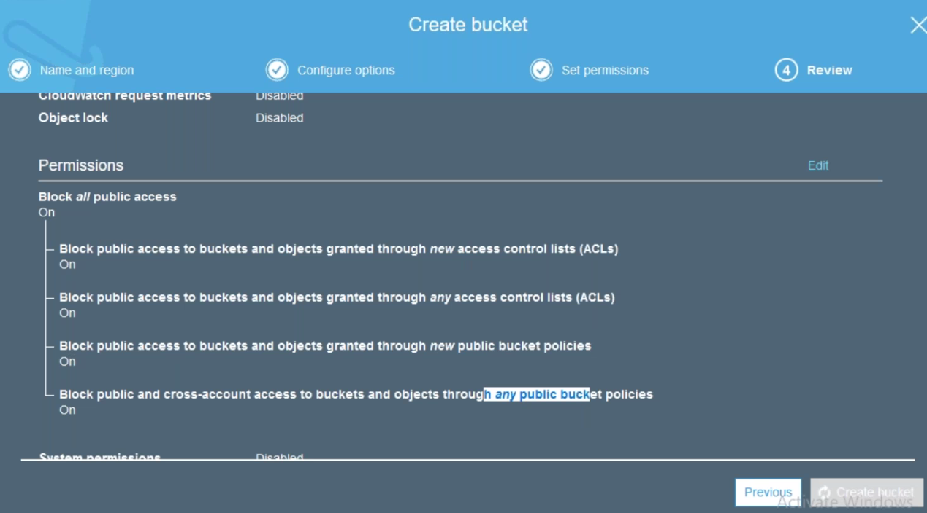

--- Click on create to create the bucket.

**Uploading files to the s3**

--- click on bucket

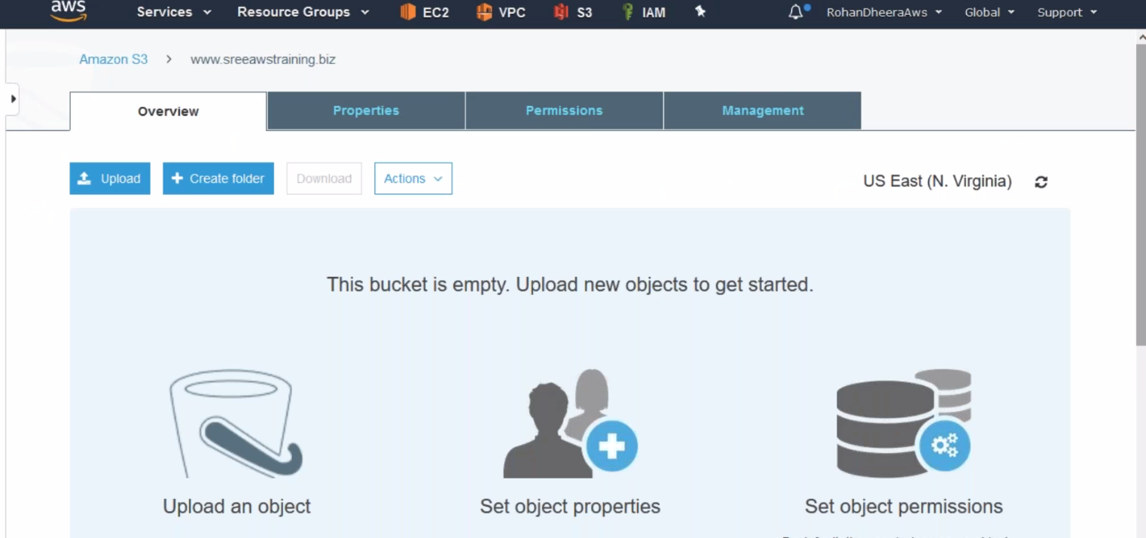

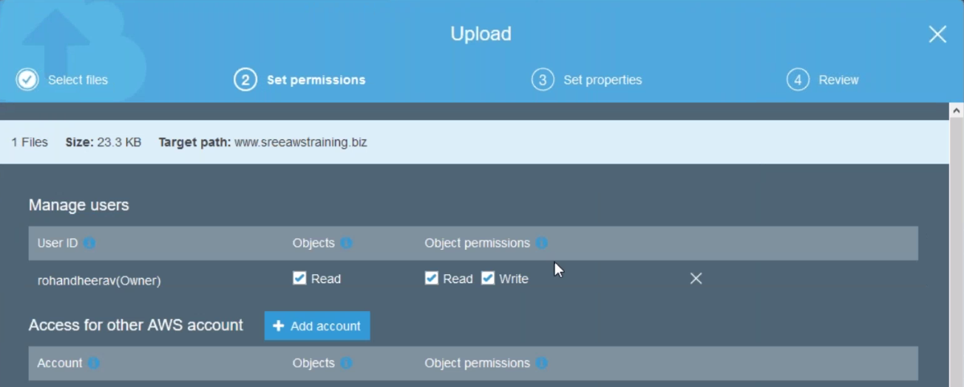

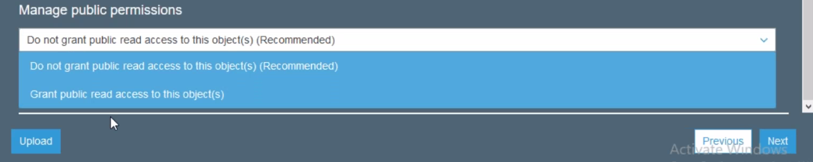

--- we can give permission to other AWS account.

--- manage public permission to bucket level or object level.

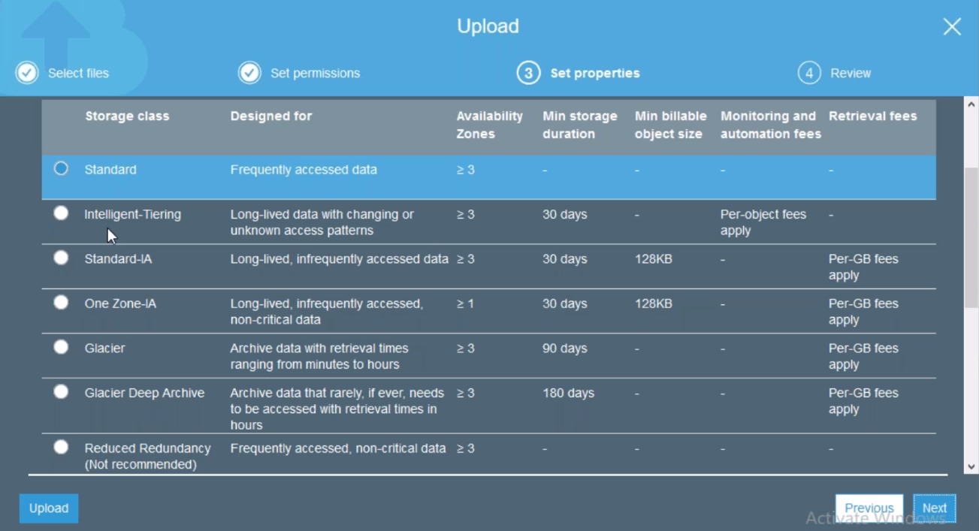

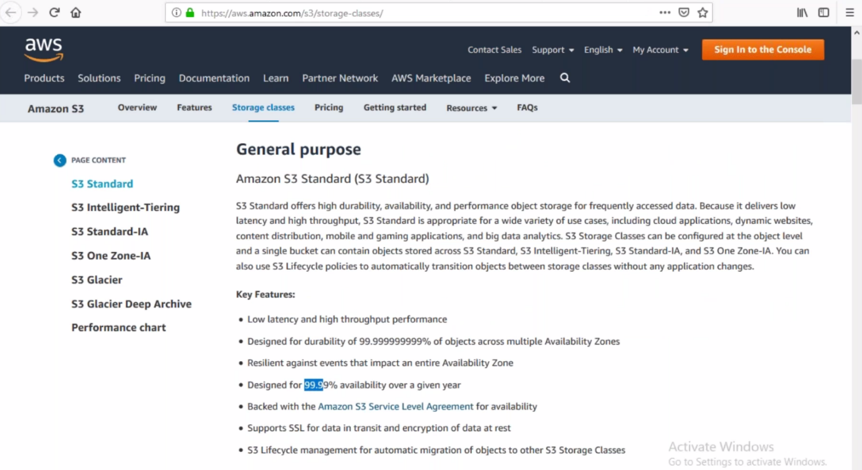

**Accessing S3 content through internet**

By default, AWS will provide URL for every uploaded content

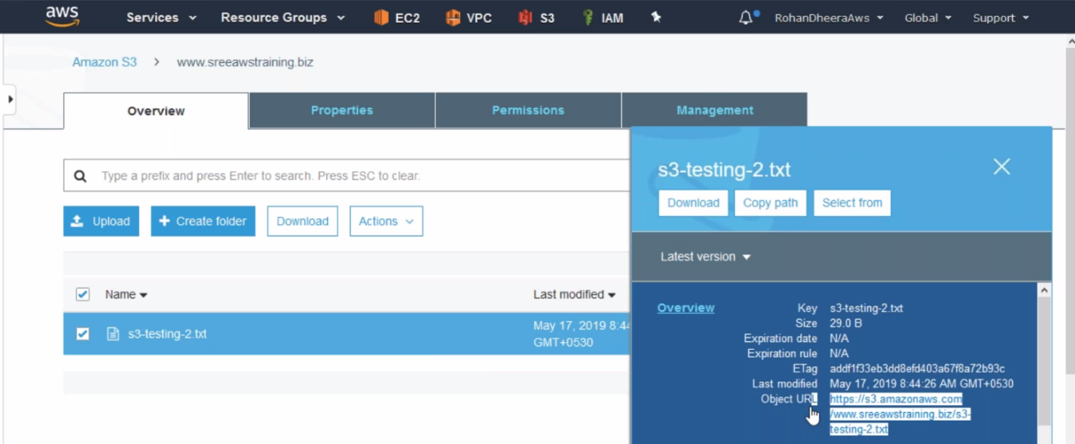

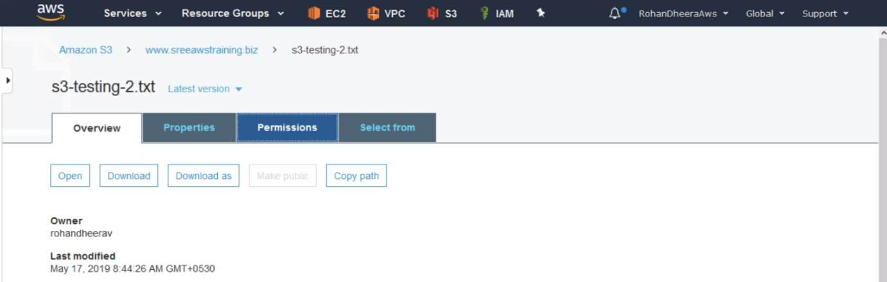

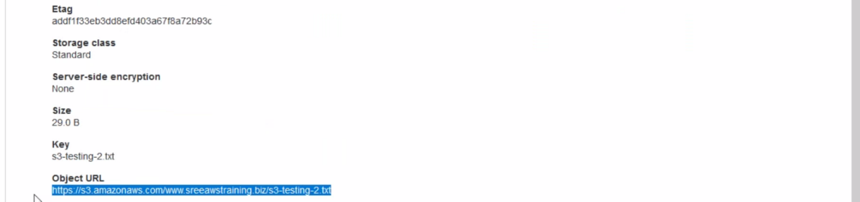

--- copy the URL and paste it on web browser for accessing the content that we uploaded in S3

**Permission**

**Block Public Access**

For accessing the content in the s3 through internet, we have to give accessing permission for content.

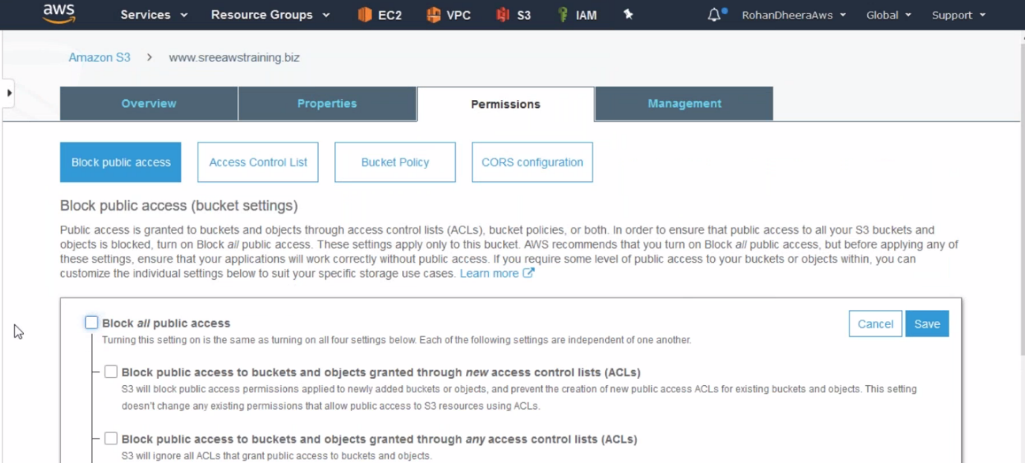

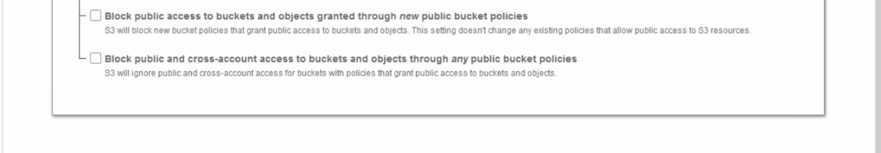

--- un check for BLOCK ALL PUBLIC ACCESS and save it.

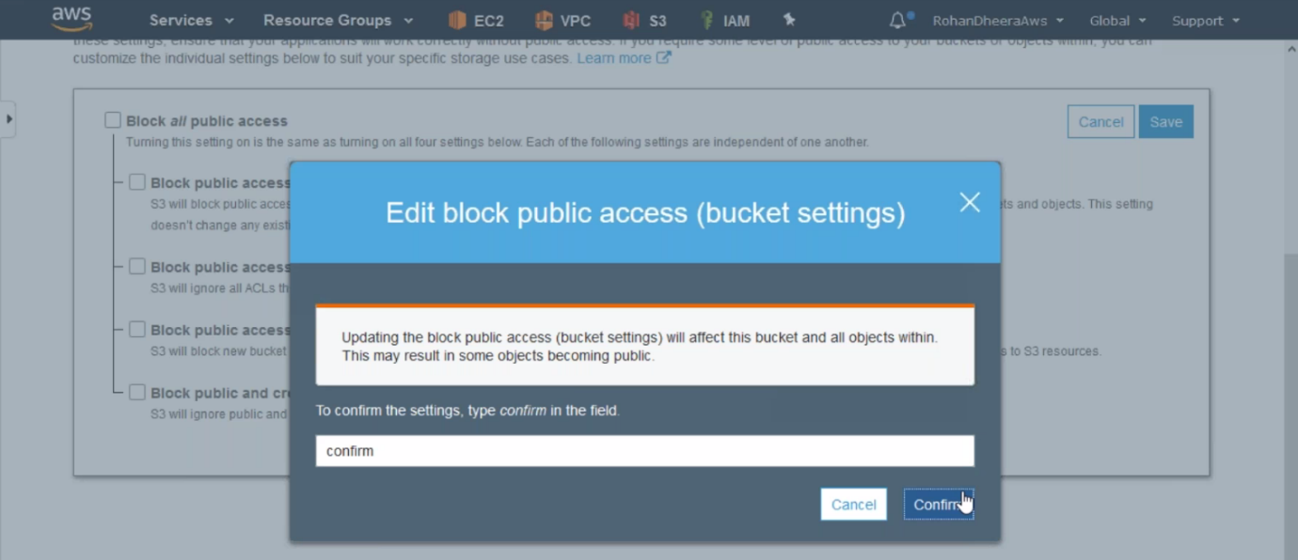

**Bucket Policy**

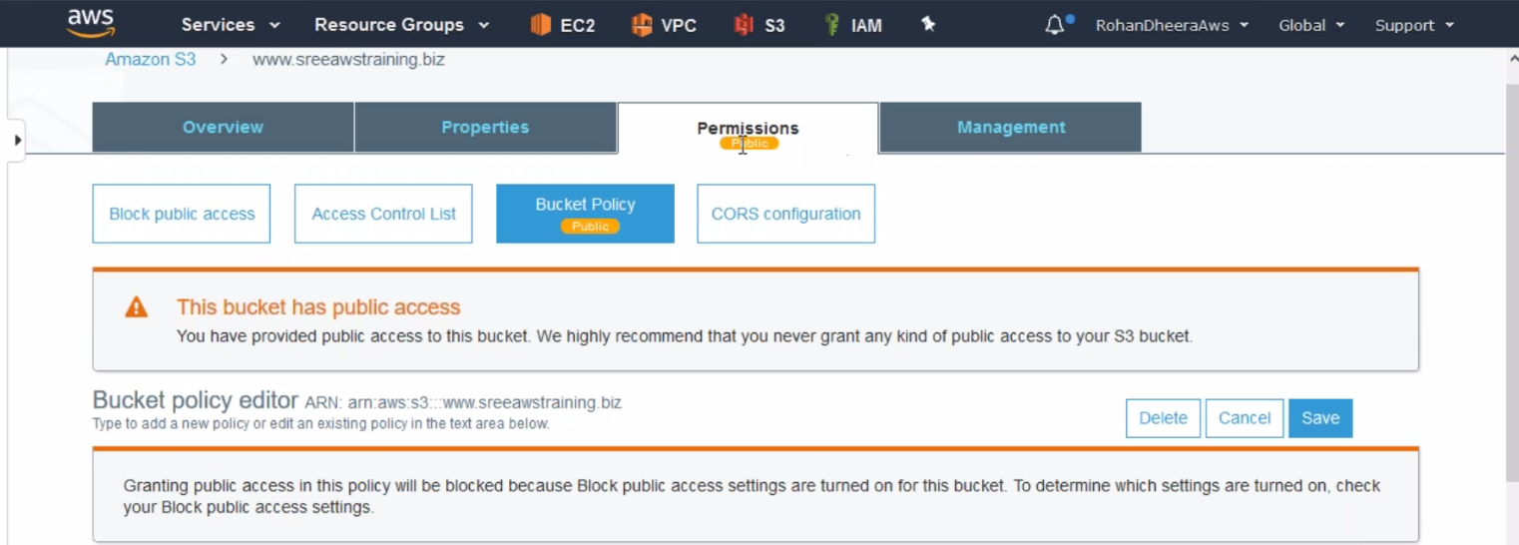

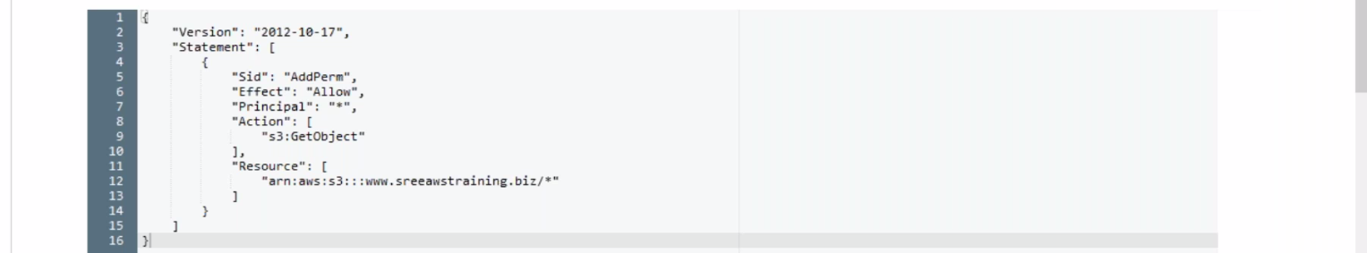

--- s3 bucket policy example – type this on google and go to the anonymous user and select the code and paste on bucket permission

--- {

"Version": "2012-10-17",

"Statement": [

{

"Sid": "PublicRead",

"Effect": "Allow",

"Principal": "*",

"Action": "s3:GetObject",

"Resource": "arn:aws:s3:::prabhu9652/*"

}

]

}

--- accessing the content through internet. Before we must un check the permission for BLOCK ALL PUBLIC ACCESSS because it will safeguard the public access.

**PROPERTIES**

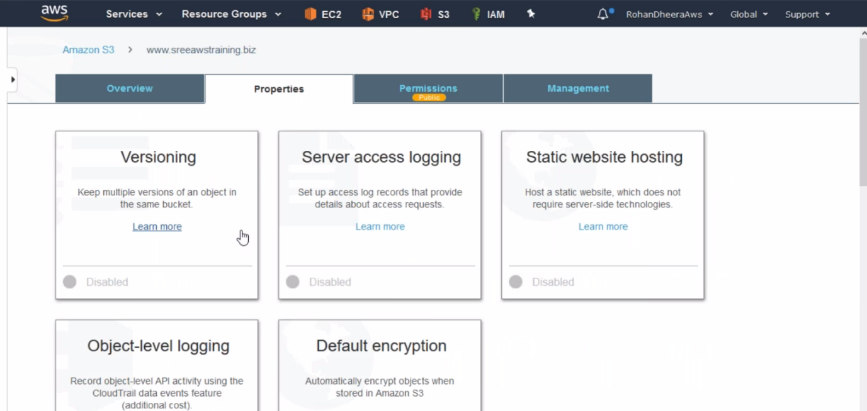

**Versioning**

The data is stored in only one location, someone came and deleted all your files. the files will be permanently gone. If changes in the storage it will save the files.

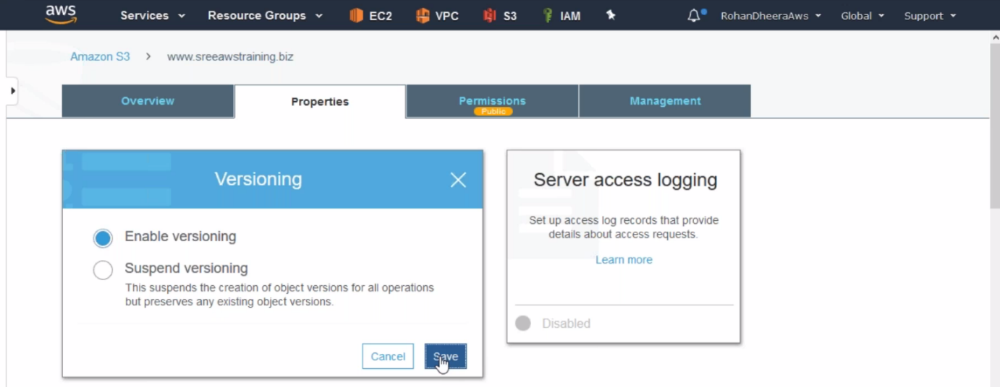

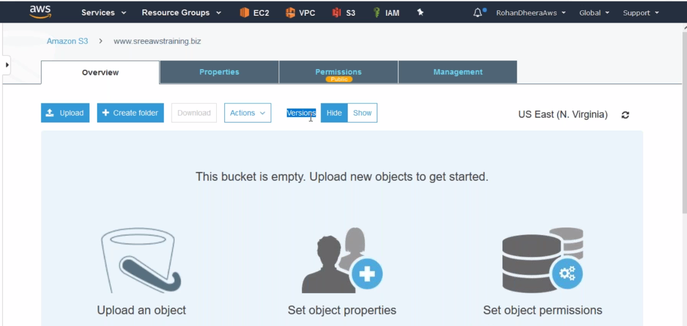

--- After enable the versioning the version tab will be shown.

**Server Access Logging**

Who is accessing your S3 bucket will be saved here, This is valid only when you host static website.

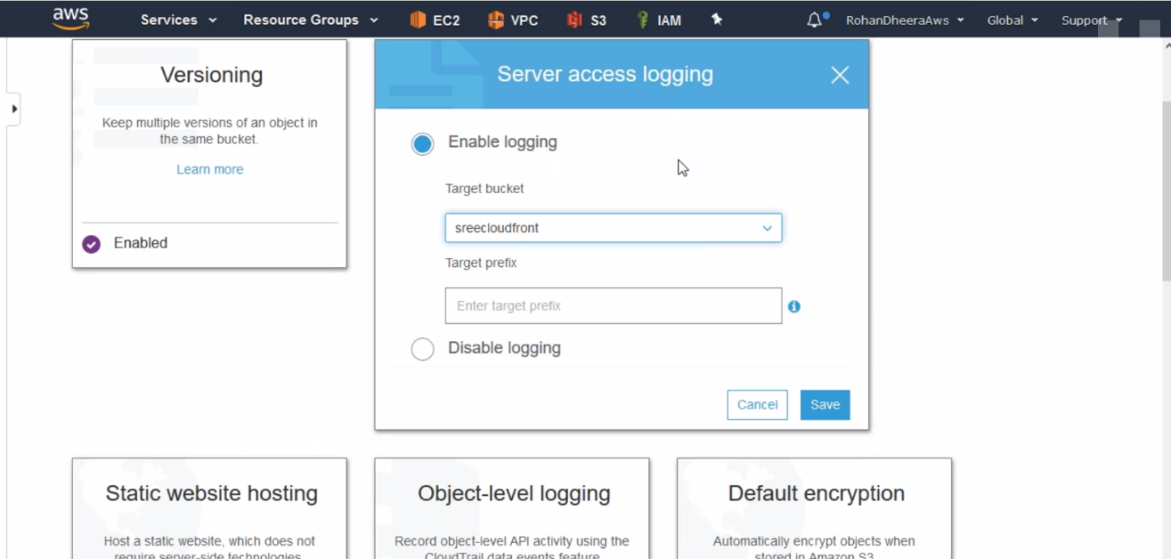

**Object Level Logging**

This will be monitoring API activity

we can access the s3 bucket using three methods. This method is very important. Because it will save all log files of particular bucket.

1) AWS console 2) AWS CLI 3) AWS SDK (software development kit) java, python ..etc

--- **QUES What is API…?**

Application programming interface

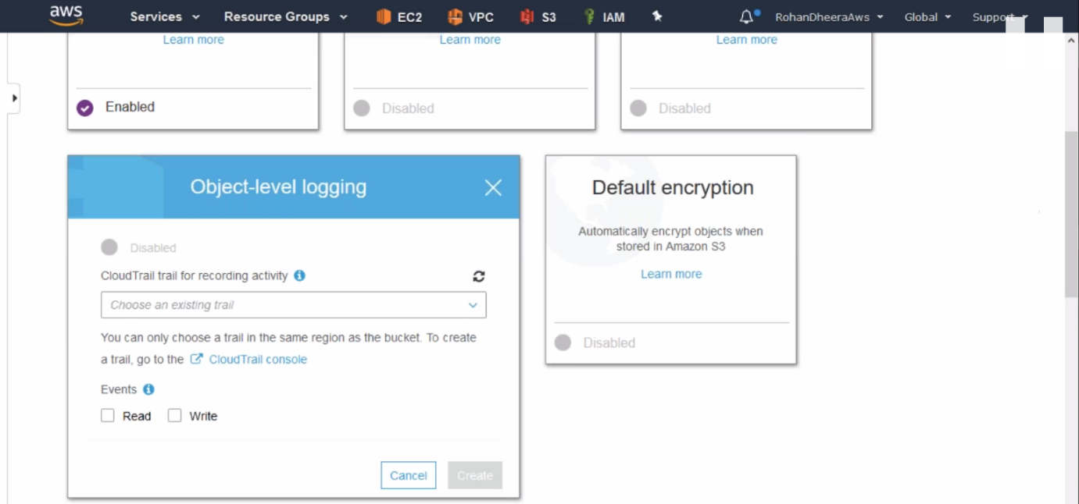

--- who is reading and writing the files saved here.

--- all the accessing details are saved in CLOUD TRAIL.

--- **Cloud trail** – this feature stores the all log details of AWS account like user login details and performed activities….etc

**Static Website Hosting**

We can host a website here.

For hosting the website, we have to create an instance, IAM user and configure the AWS in instance.

**Creating IAM User**

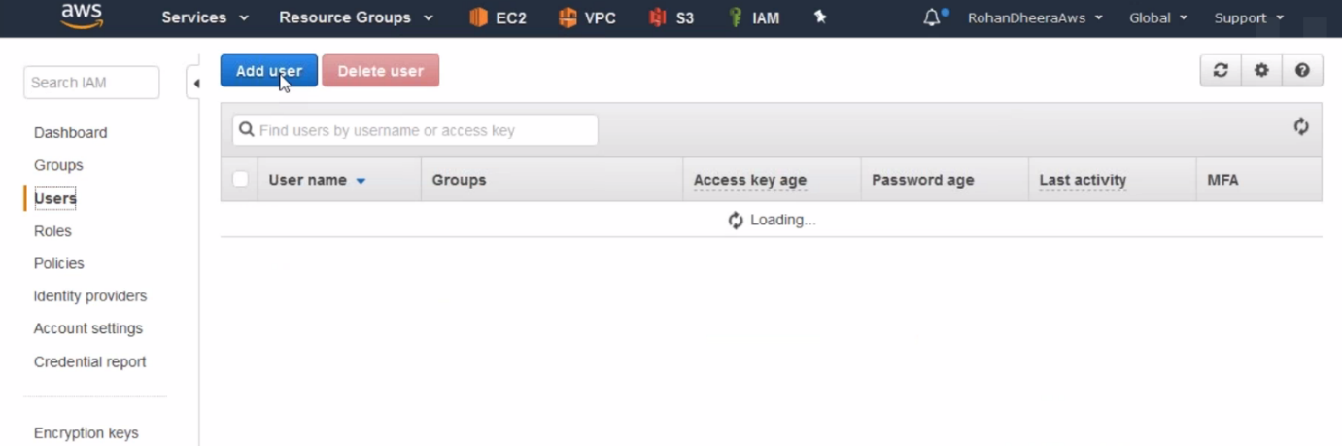

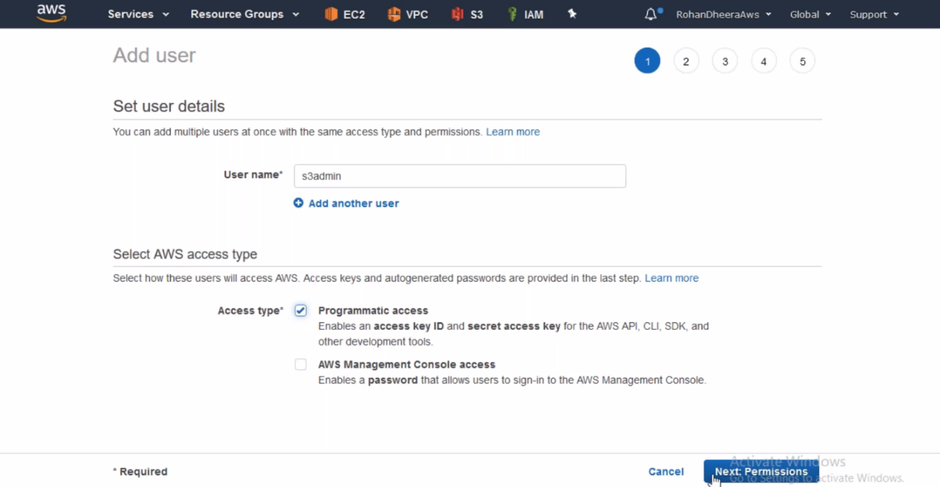

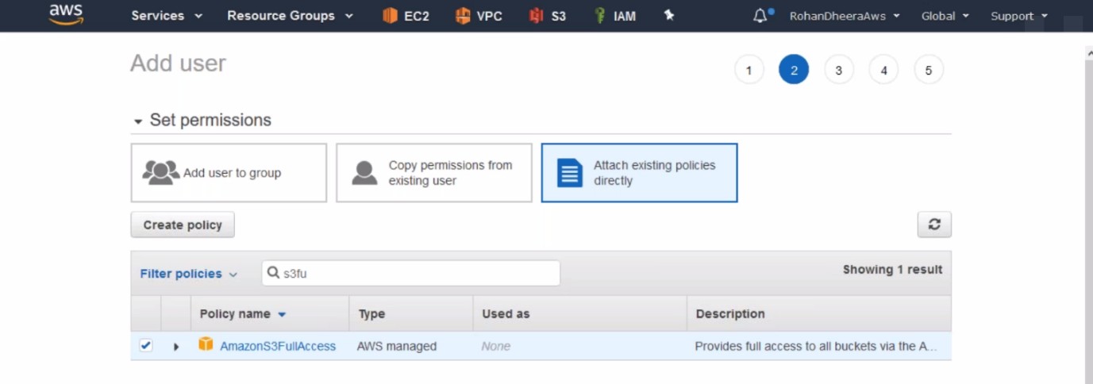

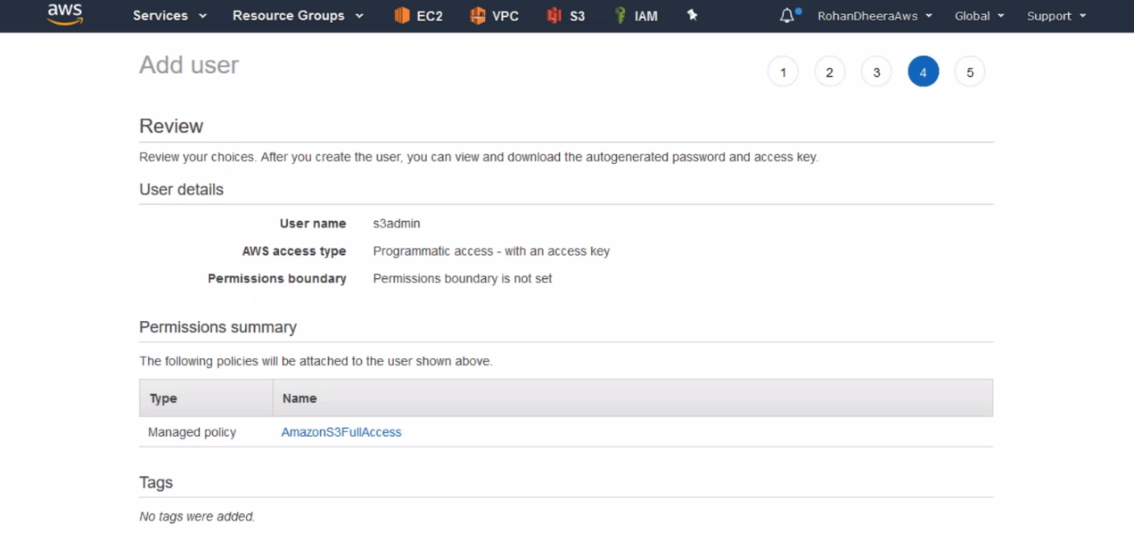

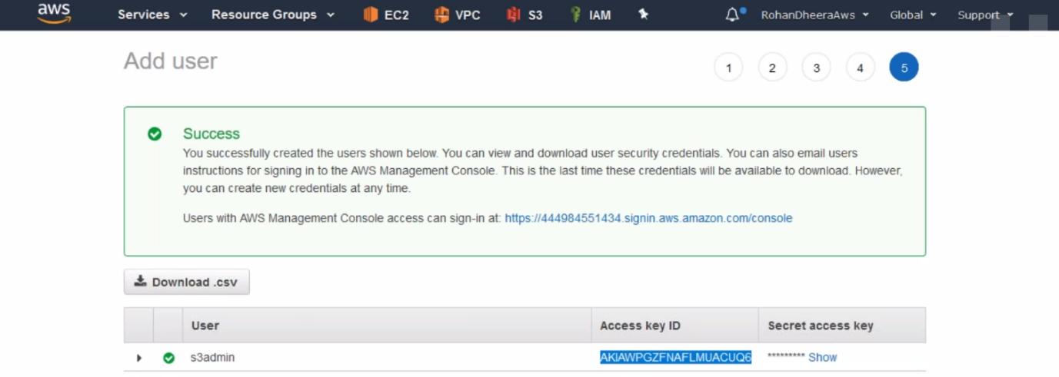

--- copy the access and secret key for further use.

--- **AWS s3 ls** – list the bucket, this command won’t work unless you configured

**AWS configure (for accessing s3 bucket)**

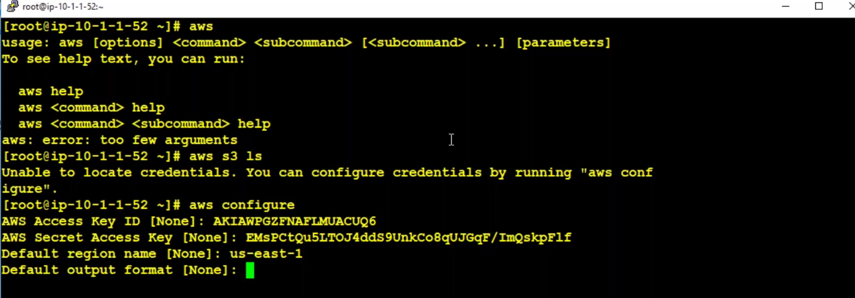

**--- aws s3 ls -**  this command will give s3 bucket information.

**Copying the data to s3 bucket**



--- **aws s3 sync s3://wildrydes-us-east-1/WebApplication/1_StaticWebHosting/website prabhu9652**

--- give your bucket name in the last

The data will be copied in the S3 bucket.

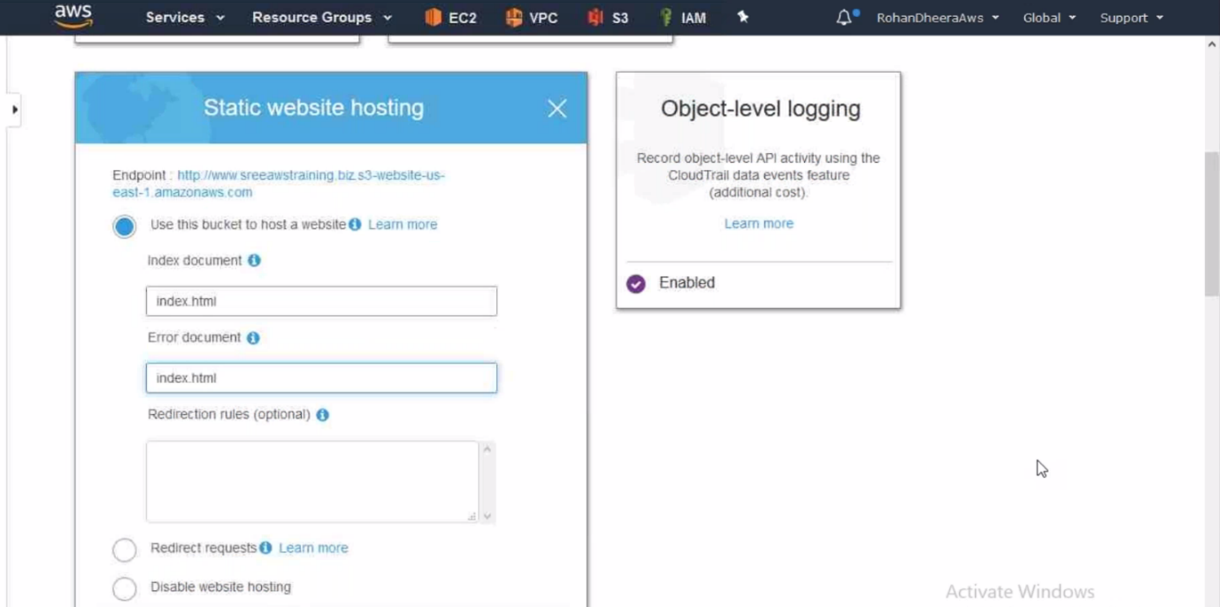

--- save it.

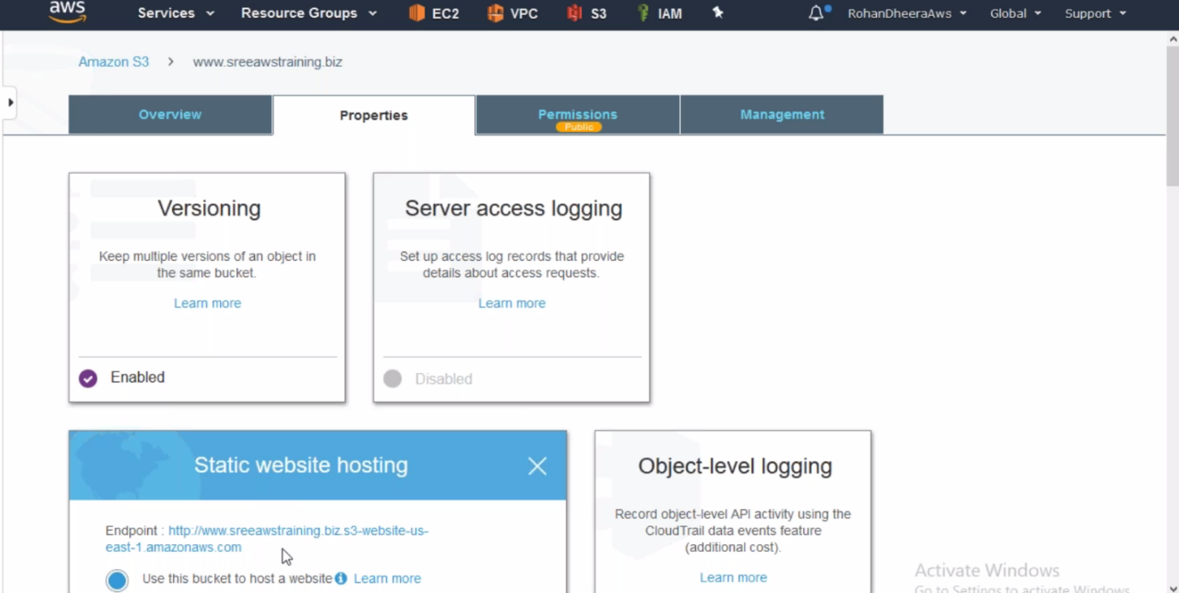

--- click on the URL to accessing the website.

--- Github wildrydes – type this on google and click on AWS-samples/AWS serverless

---AWS CLI – By default aws cli installed in linux server in case of ubuntu server we have to installed the aws cli

**Default encryption**

Two types of encryption here.

1.Clientside encryption (data will be encrypted by you and then you will send it to AWS)

2.Server side encryption ( AWS will encrypt the data )

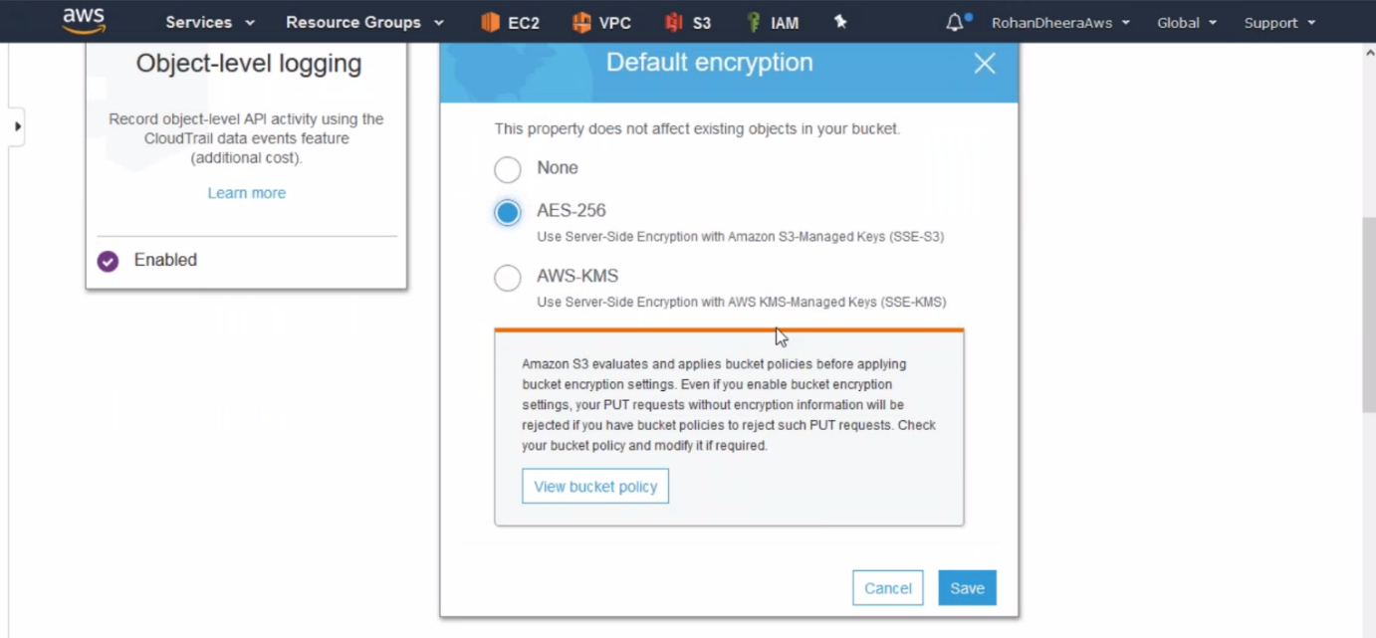

--- data will be safe when an unauthorised person trying to access the date like from the AWS side.

They won’t understand the data because its encrypted.

**Advance Setting**

**Object lock**

You have some important files and you don’t want to delete the files so you can you enable this feature to lock the files.

We have to enable this feature when you create the AWS S3.

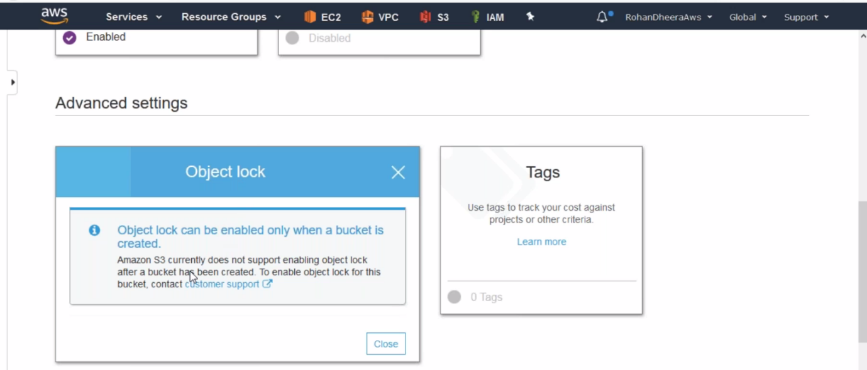

**Transfer Acceleration**

You want to upload the with higher speed.

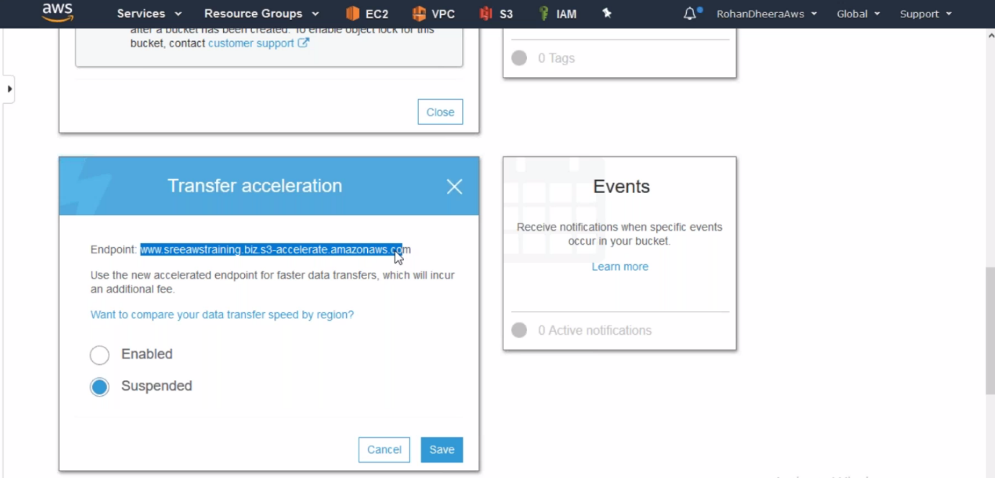

**Events**

we can send notification when someone add or delete a file…etc.

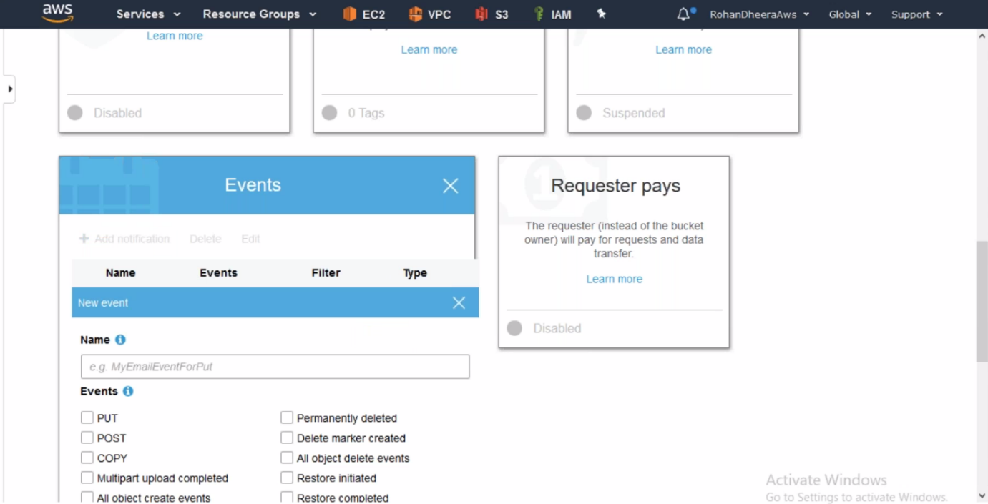

**Requester pays**

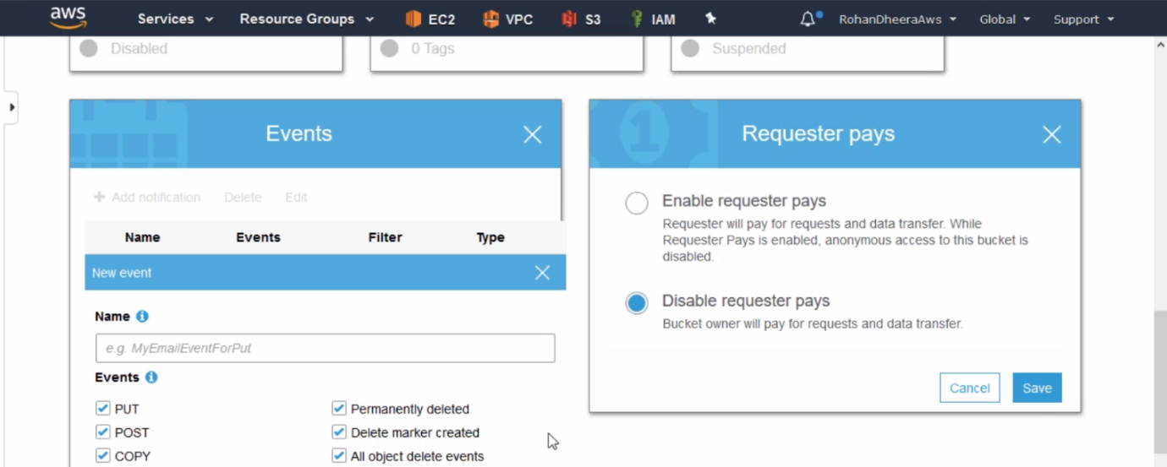

When you put some data in s3 it will be free but you want to access that data it will cost you.